**NAAN MUDALVAN ASSIGNMENT**

**NAME:** YOGESHWARAN J

**DEPARTMENT**: BE COMPUTER SCIENCE ENGINEERING

**COLLEGE**: 8151 DHANALAKSHMI SRINIVASAN INSTITUTE OF TECHNOLOGY

**NAANMUDHALVAN COURSE**: DIGITAL MARKETING

**NM ID**: 34FBD181A13027FB5114052B006D5B2B

ASSIGNMENT 1:

Create a blog or website using Blogspot and word press. Customize the theme design and post new article with 500 words.

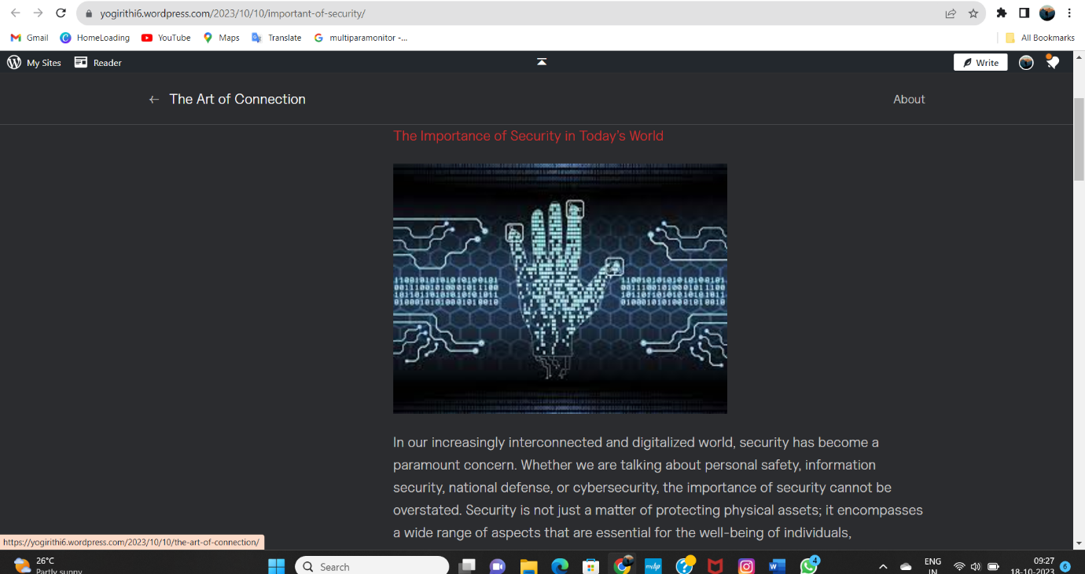URL: <https://yogirithi6.wordpress.com/2023/10/10/important-of-security/>

ASSIGNMENT 2:

Create a new Facebook business page and post one social media poster for your brand.

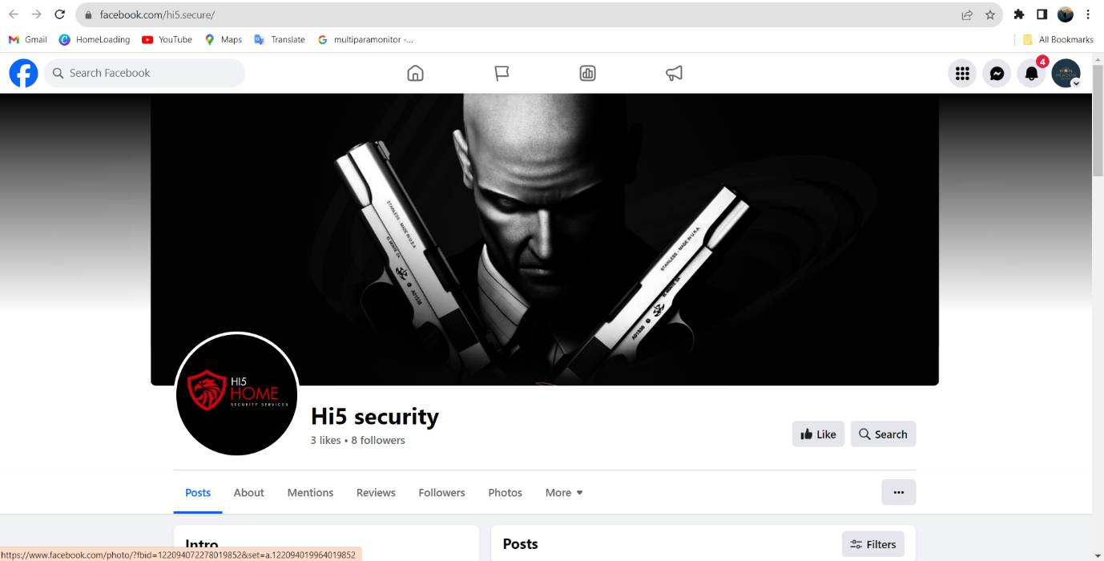URL: <https://www.facebook.com/hi5.secure/>

ASSIGNMENT 3:

Create and design a advertisement poster using Canva.

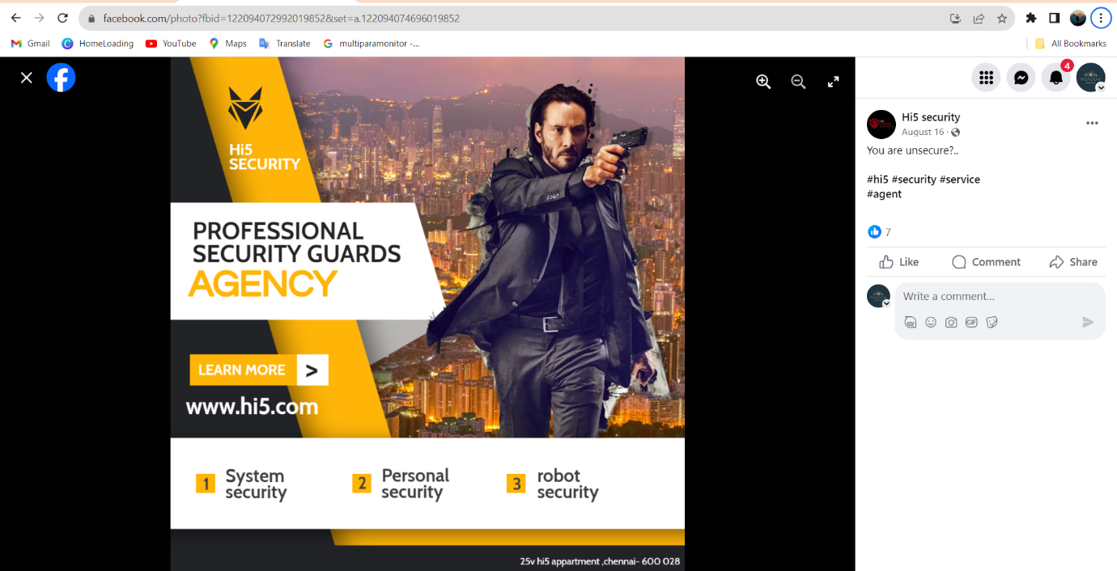URL: <https://www.facebook.com/photo?fbid=122094072992019852&set=a.122094074696019852>

ASSIGNMENT 4:

Create an E mail newsletter design using Mailchimp or Canva tool.

URL: <https://hi5security.blogspot.com/2023/09/email-newsletter.html>

